**A manual of using a template GenX script to setup and optimize surface structural models**

Canrong Qiu

cqiu@alaska.edu

This is a manual explaining how to customize a template of the GenX script to setup surface structure model. This script is specifically developed for considering sorbate adsorption on hematite (1-102) surface under different binding configurations, including monodentate, bidentate, tridentate and outer-sphere modes. Currently the local structure of a surface complex can be chosen for any sorbate with local structure from either a trigonal pyramid (Pb adsorption) or an octahedral (Sb adsorption) or tetrahedral (As adsorption).

**Inherent features of a hematite (1-102) surface**

1. Two chemically distinct domains (corresponding to two termination patterns) with each having two symmetry related domains with half unit cell step height difference.
2. The surfaces with two termination patterns could have a different step height relationship depending on how the sample is prepared (CMP or annealed).
3. Surface functional groups appears in pair, which determines that any potential binding site will have a corresponding symmetry related site to be considered explicitly with its geometrical relationship to the parent site defined by a glide plane (b glide).

**Convenience of using CTR template script**

1. You can consider as many domains as you want with the surface termination pattern specified;
2. You can freely choose different combination of binding sites. It will be very handy if you have multiple sites occurring simultaneousely (like inner-sphere and outer-sphere at the same time).
3. Different sites could be stacked up on the same domain or be distributed to different domains.
4. Water pairs could be added on top easily by specifying the reference anchor atoms.
5. Automatically group symmetrically related atoms (including sorbate atoms) together based on the glide plane symmetry
6. You can choose to impose bond valence constraint during the model fitting
7. You can specify the protonation schemes of surface atoms

**How does bond valence constraint work in the script?**

1. Pre-define a set of coordinated members
2. Specify the radius of the searching sphere (ideal bond length+offset Å by default).

The searching radius is based on the associated ideal bond length, which is added by an offset value. For example, considering the pair of O-Pb, then the ideal bond length is 2.19 Å, then the searching radius will be 2.39 Å if the offset is 0.2 Å. That way, the same oxygen atom will apply different searching radius if the other ion is different (O-Fe Vs O-Pb).

1. Calculate the bond valence sum of the atom under consideration within the searching sphere
   1. In the case of cation-anion, of which both are coordinated members, use the bond valence-bond strength relationship for the calculation of bond valence
   2. In the case of cation-anion, one of which does not belong to the coordinated members, calculate the bond valence from *step a* and then scale it by an arbitrary penalty factor.
   3. In the case of cation-cation or anion-anion (like O-O), the calculation of the bond valence is based on arbitrarily assigning a value to the r0, which is a big value (corresponding to a high bond valence value purposely as a penalty) if the inter-atomic distance is lower than the cutoff limit (the limit could be specified) or otherwise an extremely small value (the bond valence will be too small to make contributions to the total bond valence sum).
2. Calculate the numerical difference between the formal charge of the atom under consideration and the calculated total bond valence sum after counting the contribution from protonation or hydrogen bond. Such difference (higher than 1) will serve as a factor to scale the original FOM.
3. Bond valence consideration for symmetry site pair

Due to the intrinsic symmetry for rcut hematite surface, any one site will have a symmetry related site associated with it. To make the modeling more effective, both sites are assigned to a single domain instead of being assigned to two equivalent domains. So such a domain with both sites assigned is actually an average structure comprising of two symmetry domains. To correctly calculate the bond valence, only one site should be counted (you may have one surface functional group being attached to both sorbates, which will not physically occur). The way that the script deal with this problem is to select a partial set of the interfacial atoms, which include all surface atoms but one set of sorbates (metal and the associated distal oxygens possibly).

**Explanation of each global variable**

1. batch_path_head: full path to the surface files and bulk files
2. BV_TOLERANCE: a range of acceptable offset for |formal charge-bond valence sum|
3. USE_TOP_ANGLE: It will take effect only for Pb complex binding under Bidentate mode. See details in the next section.
4. FULL_LAYER_LONG: Full layer termination surface can be half unit step lower than the half layer termination (FULL_LAYER_LONG=False) or one atom layer spacing higher than the full layer termination (FULL_LAYER_LONG=True).
5. INCLUDE_HYDROGEN: Add hydrogens explicitly, and calculate the bond valence associated with a proton using an equation (not specifically assign the protonation schemes). This feature is not successful, since it will end up with too many variables (variable explosion).
6. pickup_index: index for the pre-defined binding configuration (a list with each item being an integer from 0 to 12); see the corresponding matches from the script comments.
7. sym_site_index: considering the maximum site degeneracy of two (a list of list (looks like [[]]), the inner list could be [0], [1], or [0, 1])
8. COHERENCE

It is used to set the coherent rule, which is a list with each item of a library having one key (either True or False corresponding to coherent or incoherently addition of the domains, which are specified by index numbers by the value of the library) ; magnitude of structure factor from each library will be calculated before being summed up. Some examples are as follows:

[{True:[0,1]},{False:[2,3]}]: coherent addition of domain1 and domain2, whereas incoherent addition of domain 3 and domain 4

Note that results of [{True:[0,1]},{True:[2,3]}] are different from results of [{True:[0,1,2,3]}]

Note that the chemically equivalent domains (like domain1A and domain 1B) are also added incoherently.

1. USE_BV: a switch to use bond valence constraint or not during model fitting
2. SEARCH_MODE_FOR_SURFACE_ATOMS: If using bv constraint, you can either specify the coordinated members for each surface atoms (not including sorbates) or search atoms within a spherical range with radius (2.5Å by default) adjustable.
3. DOMAINS_BV: You can pick some domains for bond valence consideration, so it is a list of domain index.
4. METAL_BV: you must set a pseudo formal charge range for metals with an incomplete shell. For example, set the formal charge of Pb to 1.2 when excluding the oxygen ligand. It is a library, and the keys are the element of different metals. It looks like {‘Pb’:[[1,1.2]], ‘Sb’:[[4.8,5]]}
5. R0_BV: A library of r0 values to be used in the bond valence bond strength relationship. The keys are the tuples of two atom elements (the order does not matter). Such a library must comprise all possible cases.
6. debug_bv: A bool value used to output the bond valence sum of atoms that are under-saturated or over-saturated. Use it as a debug tool, and remember to turn it off during fitting.
7. DOMAIN_GP:

A list used to define grouping of two domains with the same termination.

For example, [[0,1],[2,3]] means group domain1 and domain 2 together, and domain 3 and domain 4 together. After such a grouping operation, atom groups will be generated to group atoms at the same layers with symmetry defined by the glide plane described above.

1. PLOT: a switch to plot the model results with the experimental data. It will save a dump file to local disk and an external module will be called to unzip the dump file and make fancy plots. Refer to the plotting module for details.
2. PRINT_PROTONATION: It is used as a debug tool to print out all the protonation schemes of surface atoms and sorbates.
3. PRINT_BV: It is used as a debug tool to print out the bond valence of all surface atoms and the sorbates.
4. COUNT_DISTAL_OXYGEN: It is a switch to specify whether or not consider the bond valence constraint for the distal oxygens.
5. ADD_DISTAL_LIGAND_WILD: It is a switch to define how the distal oxygens will be added. If set True, distal oxygens will be added in a spherical coordinate system based on three parameters (alpha, theta and r), otherwise the positions of distal oxygens will be calculated in the associated geometrical setting (like trigonal pyramid, octahedral).
6. PRINT_MODEL_FILES: It is a switch to print out the model files in xyz format.
7. SORBATE: It is a list (looks like [‘Pb’]) used to specify the sorbate element.
8. UPDATE_SORBATE_IN_SIM: There are two different ways to fit the sorbates: First way is by doing some geometrical operations (like rotation along some axis); second way is by defining a 3d box for sorbates to move inside. If it is set to True, then the first way will be applied, otherwise the second way will be applied.
9. SORBATE_NUMBER: It is used to specify the sorbate number, which can be either 0 (clean surface), 1 (consider one site) or 2 (consider two symmetry sites).
10. O_NUMBER: It is used to specify the number of the distal oxygen, which depends on the binding configuration and the local structure of the surface complex. For example, if Sb complex (octahedral) binding on the hematite surface under tridentate mode will correspond to three distal oxygens, whereas Pb complex (trigonal pyramid) binding on the surface under Bidentate mode will correspond to a single distal oxygen.
11. SORBATE_ATTACH_ATOM: It is a list of anchor atoms for binding sorbates. A list of one, two and three items corresponds to Monodentate, Bidentate and tridentate binding mode. For outer-sphere mode, it is an empty list.
12. SORBATE_ATTACH_ATOM_OFFSET: It has the same shape as the SORBATE_ATTACH_ATOM, and it is used to define the translation offset for the anchor atoms. It can be any symbols from [‘-x’, ’+x’, ’+y’, ’-y’, None]. ‘-x’ represents translation along negative x axis for one unit, and so on for the other symbols. None represents no translation.
13. ANCHOR_REFERENCE: It is an id for an atom with a position, which will be used as a reference to create a spherical coordinate system to calculate the sobate position. It is specifically for bindentate binding configuration. Under the spherical coordinate system described above, the zero rotation angle will correspond to a sorbate at a position on a plane formed by two anchor atoms and such a reference point.
14. ANCHOR_REFERENCE_OFFSET: It is the translation offset for the anchor reference point.
15. COVALENT_HYDROGEN_RANDOM: a switch to consider protonation randomly. Bond valence sum will be calculated based on a non-protonated, single protonated or doubly protonated state, whichever will be applied if it gives rise to the most satisfactory bond valence sum.
16. POTENTIAL_COVALENT_HYDROGEN_ACCEPTOR: A list of atoms to be considered for the protonation on a random basis.
17. COVALENT_HYDROGEN_ACCEPTOR: A list of atoms to be considered for addition of protons explicitly. And it takes effect only when the COVALENT_HYDROGEN_RANDOM is set to False.
18. COVALENT_HYDROGEN_NUMBER: Define the number of protons to be added with a one to one corresponding to atoms defined in COVALENT_HYDROGEN_ACCEPTOR.
19. POTENTIAL_HYDROGEN_ACCEPTOR: a list of atoms to be considered for accepting bond valence from a possible hydrogen bond. May or may not count the hydrogen bond depending on the bond valence saturation state.
20. MIRROR: A redundant feature defined to add sorbates on the either side of edge or face.
21. WATER_NUMBER: A list of integers denoting the number of interfacial water molecules.
22. WATER_PAIR: A switch to consider adding waters singularly or in pairs.
23. REF_POINTS: A reference atoms for adding water molecules.
24. DOMAIN: It is a list of numbers (1 or 2) representing different domains with the number 1 for the half layer termination and the number 2 for the full layer termination.
25. DOMAIN_NUMBER: It is the number of domains.
26. TABLE: A switch to print the GenX importable table file according to the settings you made. The table file will be saved with a full path of “D://table.tab”.

**Rules to add sorbates**

1. Addition of water layers: you can specify even number of water molecules with a reference consisting of two atoms (then the reference point will be at the center point of those two atoms) or one atom position (then the reference point will be that position); the water positions will be calculated with an alpha angle in degree and a vertical shift in Å and a R constrained by the condition of |y1-y2|=0.5.
2. Addition a metal in a Monodentate/Bidentate mode/tridentate mode/outer-sphere mode: with a local structure of trigonal pyramid for Pb sorbate or octahedral for Sb sorbate
   1. Monodentate: not tested yet, so the code could be buggy
   2. Bidentate: you need two anchor atoms and one reference atom so that you can set the coordinated system properly.
      1. Pb case: you need specify arguments of top_angle (or edge length R under USE_TOP_ANGLE=False ), phi (rotation angle), edge_offset, and angle_offset, edge_offset2 (angle_offset and edge_offset2 are relevant to the distal oxygen)
      2. Sb case: you have only one freedom that is phi (rotation angle)
   3. Tridentate: you need three anchor atoms but don’t need reference atom here
      1. Pb case: Not tested
      2. Sb case: you have no freedom in this case
   4. Add distal oxygen wildly: you can choose to add distal oxygen wildly by setting ADD_DISTAL_LIGAND_WILD=True; then for each distal oxygen pairs (two oxygens) you need r, theta and phi arguments and the position of the associated metal to calculate the ligand position.

**Naming rules**

1. IDs for atoms within each domain
2. Surface atoms
   1. Half layer termination. O1_n_m_D1A: n can be any number from 1 to 20, and m can be either 0 (top slab) or (lower slab). Fe1_n_m_D1A: n can be any number from [4, 6, 8, 9, 10, 12], and m has the same definition as surface oxygens. The suffix will tell you the information of domain is affiliated to. For example, D1A means that it belongs to the domain 1 with higher symmetry slab (A or lower symmetry slab if it is suffixed by B).
   2. Full layer termination (long): O1_n_m_D1A: n can be any number from 1 to 20, and m can be either 0 (top slab) or (lower slab). Two more cases are O1_11_t_D1A and O1_12_t_D1A specifically representing the two terminal oxygens. Fe1_n_m_D1A: n can be any number from [2, 3, 4, 6, 8, 9, 10, 12], and m has the same definition as surface oxygens.
   3. Full layer termination (short): O1_n_m_D1A: n can be any number from 1 to 20 (5-20 for top slab, 1-20 for lower slab), and m can be either 0 (top slab) or (lower slab). As a comparison, now two terminal oxygens have ids of O1_5_0_D1A and O1_6_0_D1A. Fe1_n_m_D1A: n can be any number from [2, 3, 4, 6, 8, 9, 10, 12], and m has the same definition as surface oxygens.
3. Sorbates: Pbn_D1A, n can be any integer number.
4. Distal oxygens: HOn_Pbm_D1A, n and m can be any integer number. It means nth (like third if n=3) distal oxygen of Pbm (like Pb1).
5. Waters: Osn_D1A, n can be any integer number from 1.
6. Atom groups
7. Surface atoms:

gp_O1O2_O7O8_D1: group atoms of O1 and O2 from domain1A to O7 and O8 from domain1B together using the associated glide plane symmetry relationship for dxdydz movements.

gp_O1O2_O7O8_D1_D2: group O1, O2, O7 and O8 for domain 1 and domain 2 (including A, B subdomains) together using the associated glide plane symmetry relationship for dxdydz movements.

1. Sorbates:

gp_sorbates_set1_D1: group first set (what “set1” means) of sorbates (including metals and distal oxygens) together without considering symmetry relationship

gp_Pb_D1 or gp_Sb_D1: group sorbates (one or two) together based on glide plane symmetry relationship.

gp_Pb1_D1_D2 or gp_Sb1_D1_D2: group first (usually the only) sorbate from domain 1 (A and B subdomains) and domain 2 (A and B subdomains) together using glide plane symmetry relationship. Note that you want to group two domains together always because you want to avoid steric unfeasibly situation when including two set of sorbates within one unit cell. Therefore, you split two set of sorbates into two symmetry related domains.

1. Distal oxygens:

gp_HO1_D1: group first distal oxygen (i.e. HO1_Pb1 and HO1_Pb2) together based on glide plane symmetry operation.

gp_HO1_D1_D2: refer to gp_Pb1_D1_D2

1. Waters:

gp_Os1_D1: group Os1 together from domain 1 (A and B subdomains)

gp_Os1_D1_D2: refer to gp_Pb1_D1_D2

1. Fitting parameters

For each domain, there will be a user-defined parameter instance being created automatically. The parameters inside each instance dynamically change upon different binding configuration. Besides that, there are the other two par instance, i.e. inst (through which you set the scaling factor for your fitting) or rgh (through which you set the roughness of your structure model). More details are stated as below.

1. inst.set_inten: set the overall scaling factor during model fitting
2. rgh.setBeta: set the roughness for the surface (usually <0.2)
3. rgh_domain**N**.setWt:set the domain waight for domain**N**

Parameters for binding in monodentate mode (MD)

It has never been tested for binding cases under MD mode. The features are not well coded, and the existing ones could be buggy. It should be accomplished in the future once we are working on a case under this mode.

Parameters for binding in bidentate mode (BD)

1. rgh_domainN.setAnchor_offset_**BD**_n:set anchor offset (read geometry section for detail) for sorbate set n (n should be even number from 0. 0 means using this par for sorbate 0 and sorbate 1, whileas 2 means using this par for sorbate 2 and sorbate 3, and so on).

And note that the BD in the par name means setting this par under bidentate mode, so TD means tridentate mode and MD means Monodentate mode and OS means outersphere mode. Such naming rule is implicitly applied hereafter.

Effect of this par will shift the sorbate and distort the local structure of the sorbate.

1. rgh_domainN.setAngle_offset_**BD**_n: set angle offset for first distal oxygen to distort the local structure.
2. rgh_domainN.setAngle_offset2_**BD**_n: set angle offset for second distal oxygen to distort the local structure.
3. rgh_domainN.setOffset_**BD**_n: set offset for first distal oxygen, and it will change the sorbate-oxygen bond length.
4. rgh_domainN.setOffset2_**BD**_n: set offset for second distal oxygen, and it will change the sorbate-oxygen bond length.
5. rgh_domainN.setPhi_**BD**_n: set rotation angle for sorbate species including metal and the associated distal oxygens). The polyhedral will be rotated about an axis (formed by anchor atoms) by this degree. And note that the zero rotation angle is arbitrarily set so that the maximum sorbate-surface cation distance is maintained.
6. rgh_domainN.setTop_angle_offset_**BD**_n: set a offset to the ideal top angle. For example, the ideal top angle for tetrahedral is 109.5 ° . An offset to this ideal value will make a distortion to the local structure.
7. rgh_domainN.setR(Theta, Phi)1_m_**BD**_n: set the coordinates (r, theta and phi) in a spheric coordinate system for distal oxygens if under ADD_DISTAL_WILD mode.

Depending on the number of distal oxygens, you may have multiple r, theta and phi in the setting, so the m can be any integer number higher than 1.

Parameters for binding in tridentate mode (TD)

1. rgh_domainN.setDr1(2 or 3)_oct_**TD**_n: bond length change in unit of Å along the vector from sorbate to the associated distal oxygen in the case of octahedral local structure.
2. rgh_domainN.setDr_tetrahedral_**TD**_n: bond length change in unit of Å along the vector from sorbate to the associated distal oxygen in the case of tetrahedral local structure.
3. rgh_domainN.setTop_angle_**TD**_n: set the top angle (O-M-O) in the case of trigonal pyramid local structure.
4. rgh_domainN.setR(Theta, Phi)1_m_**TD**_n: set the coordinates (r, theta and phi) in a spheric coordinate system for distal oxygens if under ADD_DISTAL_WILD mode.

Depending on the number of distal oxygens, you may have multiple r, theta and phi in the setting, so the m can be any integer number higher than 1.

Parameters for binding in outersphere mode (OS)

1. rgh_domainN.setRot_x(y,z)_**OS**_n:set the rotation angle about x(y,z) axis passing through the sorbate for an octahedral structure. It can be any value in [0,360].
2. rgh_domainN.setR0_**OS**_n: set a bond length in Å for an outersphere local structure.
3. Rgh_domainN.setCt_offset_dx(dy,or dz)_**OS**_n: shift the sorbate along with the distal oxygens in x, y and z direction. Note here the values are in frational unit. So the widest range for dxdy is [-0.5,0.5].

Parameters for group instance

Note that the fitting paprameters for any one group instance include dx, dy, dz (for group atom movements in x y and z direction), u (thermal factor) and oc (occupancy).

For example, a group instance of gp_O1O2_O7O8_D1 could be called in the following ways to control the position, thermal factor and occupancy of group atoms:

gp_O1O2_O7O8_D1.setdx

gp_O1O2_O7O8_D1.setdy

gp_O1O2_O7O8_D1.setdz

gp_O1O2_O7O8_D1.setu

gp_O1O2_O7O8_D1.setoc

**Step by step procedures to set up model**

Easy easy, just fill up the main setup zone in the template script.

**######################**Explanation of each variable inside main setup zone**###################**

running_mode(bool)

if true then disable all the I/O function

SORBATE(list of single element to be considered for modelling)

element symbol for sorbate

pickup_index(a list of index list with items from the match index table above)

representative of different binding configurations for different domains

make sure the half layer indexes are in front of the full layer indexes

In this new version, you can have multiple sites being assigned simultaneously on the same domain

For example,in the case of [[0,6,6],[4],[10,14]] there are three sites assinged to domain1, i.e. bidentate site and the other two outer-sphere site

sym_site_index(a list of list of [0,1])

a way to specify the symmetry site on each domain

you may consider only site pairs in this version ([0,1])

The shape is the same as pickup_index, except that the inner-most items are [0,1] instead of match index number

It will be set up automatically

full_layer_pick(a list of value of either None, or 0 or 1)

used to specify the full layer type, which could be either long slab (1) or short slab (0)

don't forget to set None for the half layer termination domain

Again Nones if any must be in front of numbers (Half layer domains in front of full layer domains)

OS_X(Y,Z)_REF(a list of None,or any number)

set the reference coordinate xyz value for the outer-sphere configuration, which could be on either HL or FL domain

these values are fractional coordinates of sorbates

if N/A then set it to None

such setting is based on the symmetry operation intrinsic for the hematite rcut surface, which have the following relationship

x1+x2=0.5/1.5, y1-y2=0.5 or -0.5, z1=z2

The shape is like [[],[]], each item corresponds to different domains

The number of items within each domain is twice (considering symmetry site pair) the number of sorbate for that domain

DOMAIN_GP(a list of list of domain indexs)

use this to group two domains with same surface termination (HL or FL) together

the associated atom groups for both surface atoms and sorbates will be created (refer to manual)

This feature is not necessary and so not supported anymore in this version.

water_pars(a lib to set the interfacial waters quickly)

you may use default which has no water or turn the switch off and set the number and anchor points

USE_BV(bool)

a switch to apply bond valence constrain during surface modelling

COVALENT_HYDROGEN_RANDOM(bool)

a switch to not explicitly specify the protonation of surface functional groups

different protonation scheme (0,1 or 2 protons) will be tried and compared, the one with best bv result will be used

BV_OFFSET_SORBATE(a list of number)

it is used to define the acceptable range of bond valence sum for sorbates

[bv_eachbond*N_bonds-offset,bv_eachbond*N_bonds] will be the range

set a random number for a clean surface (no sorbate), but don't miss that

SEARCH_RANGE_OFFSET(a number)

used to set the searching range for an atom, which will be used to calculate the bond valence sum of sorbates

the radius of the searching sphere will be the ideal bond length plus this offset

commands(a list of str to be executed inside sim function)

eg. ['gp_O1O2_O7O8_D1.setoc(gp_Fe4Fe6_Fe10Fe12_D1.getoc())']

used to expand the funtionality of grouping or setting something important

USE_COORS(a list of 0 or 1)

you may want to add sorbates by specifying the coordinates or having the program calculate the position from the geometry setting you considered

eg1 USE_COORS=[[0]]*len(pickup_index) not use coors for all domains

eg2 USE_COORS=[[1]]*len(pickup_index) use coors for all domains

eg3 USE_COORS=[[0],[1],[1]] use coors for only domain2 and domain3

COORS(a lib specifying the coordinates for sorbates)

keys of COORS are the domain index and site index, ignore domain with no sorbates

len(COORS[(i,j)]['sorbate'][0])=1 while len(COORS[(i,j)]['oxygen'][0])>=1, which is the number of distal oxygens

make sure the setup matches with the pick_up index and the sym_site_index as well as the number of distal oxygens

if you dont consider oxygen in your model, you still need to specify the coordinates for the oxygen(just one oxygen) to avoid error prompt

O_NUMBER_HL/FL(a list of list of [a,b],where a and b are integer numbers)

one to one corresponding for the number of distal oxygens, which depend on local structure and binding configuration

either zero oxygen ligand or enough ligands to complete coordinative shell

COUNT_DISTAL_OXYGEN(bool)

True then consider bond valence also for distal oxygen,otherwise skip the bv contribution from distal oxygen

ADD_DISTAL_LIGAND_WILD(list of bool)

the distal oxygen could be added by specifying the pars for the spherical coordinate system (r, theta, phi), which is called wild here, or be added

in a specific geometry setting for a local structure (like tetrahedra)

you can specify different case for different domains

and this par is not applicable to outersphere mode, which should be set to None for that domain

DOMAINS_BV(a list of integer numbers)

Domains being considered for bond valence constrain, counted from 0

BOND_VALENCE_WAIVER(a list of oxygen atom ids [either surface atoms or distals] with domain tag)

When each two of thoes atoms in the list are being considered for bond valence, the valence effect will be ignored no matter how close they are

Be careful to select atoms as bond valence waiver

#####################################################################################################################

Print the table file (set the running mode to False, then a “table.tab” file will be made and saved in D:// by default after you hit simulation button) and import it, and edit the fitting parameter (a lot of redundant items need to be deleted) table if necessary.

Set the running mode back to True, and submit the file to super computer system for model optimization.

Way to go!!!!

**Guides for code extension for future**

**Appendix**

Potential binding sites pairs on half layer (left) and short full layer (right) termination surface, numbers in circle (bidentate) or pantagam (tridentate) are the associated matching index used in the script.

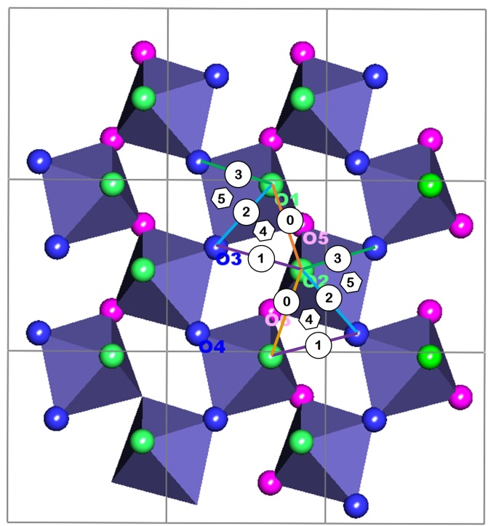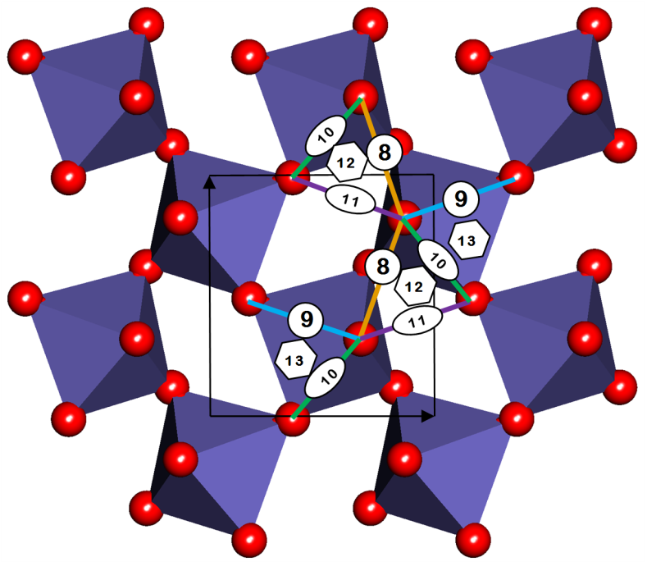

Geometric solutions to setting sorbate on surface under different binding modes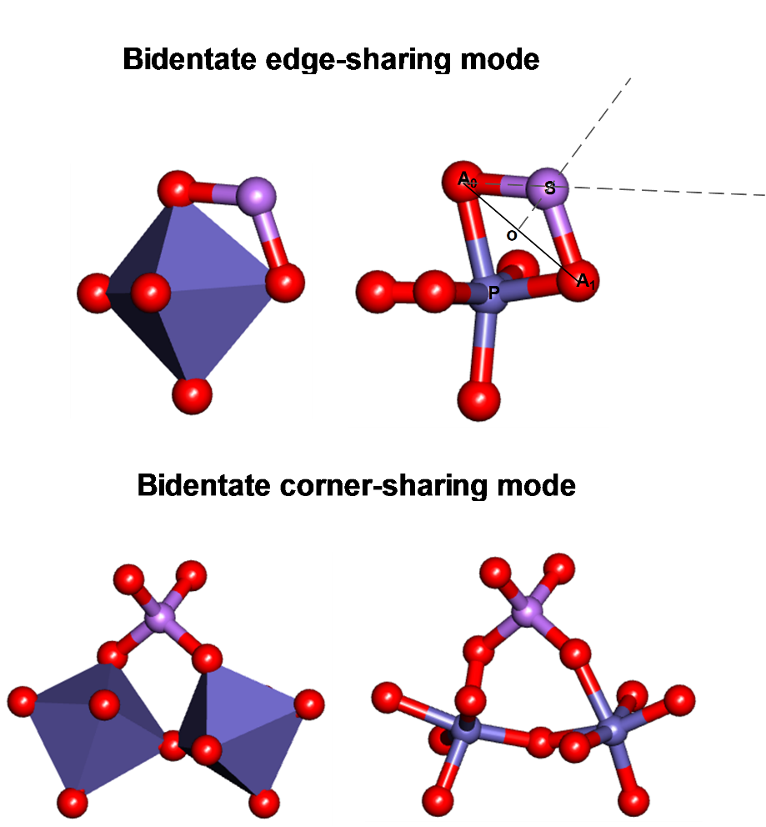

There are two different motions the sorbate could undergo in a symmetric way (as opposed to distorted way). One is having the sorbate rotate along the anchor axis (A0A1). Once the sorbate is rotated, the distal oxygens attached to this sorbate will be rotated in the exactely same way. You may need a reference point to define the zero rotation angle. By default, the zero rotation angle is obtained when the reference point (P), two anchor points (A0 and A1) and the sorbate are coplanar. It is obvious, at zero rotation angle, the distance between the sorbate and the reference point is maximum. Besides rotation motion, the sorbate can undergo stretching via moving the sorbate along the OS line, where O is the center point of A0A1. As a result, the top angle changes (A0SA1). The associated fitting parameters are top_angle for the trigonal pyramid case and top_angle_offset (offset from the ideal 109.5 degree) for the tetrahedral case.

To distort the local structure, the sorbate is allowed to move along A0S direction.